# Do Humans Maintain a Representation of the Air Drag in their Environment?

Borja Aguado¹, Björn Jörges², Joan López-Moliner¹*

¹ Vision and Control of Action (VISCA) group, Department of Cognition, Development and Psychology of Education, Institut de Neurociències, Universitat de Barcelona, Ps. Vall d'Hebron 171, 08035 Barcelona, Catalonia, Spain.

² Center for Vision Research, York University, 4700 Keele Street, Toronto, ON M3J 1P3, Canada

*Corresponding Author

## Introduction

The importance of ecologically valid stimuli for the study of interceptive actions is self-evident. Nonetheless, many studies neglect air drag when simulating stimuli in virtual reality. While this can facilitate some aspects of setup and analysis, it may lead to systematic errors in results. There is evidence that humans represent and use different physical properties of their environment, such as the size of known objects (Hosking & Crassini, 2010; López-Moliner, Field, & Wann, 2007), their mass (Neupärtl, Tatai, & Rothkopf, 2020), density (Peters, Ma, & Shams, 2016), gravity (Bosco et al., 2015; Gómez & López-Moliner, 2013; Indovina et al., 2005; Jörges & López-Moliner, 2019; Jörges & López-Moliner, 2017, 2020; La Scaleia, Zago, Moscatelli, Lacquaniti, & Viviani, 2014; Lacquaniti et al., 2013; McIntyre, Zago, & Berthoz, 2001; McIntyre, Zago, Berthoz, & Lacquaniti, 2003; Mijatovic, La Scaleia, Mercuri, Lacquaniti, & Zago, 2014; Senot, Zago, Lacquaniti, & McIntyre, 2005; Senot et al., 2012; Zago, La Scaleia, Miller, & Lacquaniti, 2011) or the direction of light (Adams, Graf, & Ernst, 2004) in their interactions with the environment.

Air drag is an umbrella term for different effects that act opposite to the motion direction of a moving object. Different types of air drag are parasitic drag, lift-induced drag and wave drag. Parasitic drag is the force that acts upon bodies that moves through liquids (including the air). Lift-induced drag occurs when a body redirects airflow, as for example wings do. Wave drag is present when objects move around the speed of sound, as well as at the borders between different liquids. For everyday interception tasks, parasitic drag is most relevant. It is computed as follows:

|  |  |
| --- | --- |
|  | [1] |

is the drag coefficient of the respectively object; it is calculated based on the density of the surrounding fluid (1.225 kg/m³ at a temperature of 15° C in the case of air), the drag coefficient , which depends on the object shape, and the radius *r*. The drag force relates thus quadratically to velocity and diameter of the target: faster objects with a bigger cross-section are affect much more strongly by air drag than smaller, more slowly moving objects. For completeness sake, the so-called Magnus force should not be left unmentioned, which is responsible, for example, for topspin effects in ball sports like tennis. Magnus forces act upon objects that spin while moving through liquids and can drive a tennis ball downwards in an unexpected fashion. However, the current study neglects Magnus forces and focusses entirely on air drag.

Air drag can thus be envisioned as negative, dynamically developing acceleration acting opposite to the direction of motion of the target. As such, it is in two ways different from the other very common acceleration in our environment, gravity: First, the direction of the gravitational acceleration is always acting in the same direction, independently of object motion. Second, its force does not depend on the velocity of the target.

The present study aims to investigate whether air drag is, like gravity, mass or density, among the physical properties of the environment represented by the brain. We expect systematic errors when no air drag is simulated, and an accurate performance when air drag is simulated (Hypothesis 1). Furthermore, if humans represent air drag, it stands to reason that they also represent air ­drag-relative properties of known objects such as their density and their respective drag coefficient. We thus expect to observe systematic errors when the air drag acting upon a simulated object does not correspond to its appearance (e. g. a ball with the appearance of a tennis ball, but air drag-relevant properties of a basketball; Hypothesis 2).

## Methods

## Participants

We tested n = 20 participants. They were between ____ and ____ years old and had all normal or corrected-to-normal vision. All of them were Psychology students at University of Barcelona and could participate in research activities to acquire course credits. None of the participants were stereoblind .

Apparatus

We presented overlaid images on a back-projection screen (244 cm tall and 184 cm wide) with two Sony laser projectors (VPL-FHZ57). They provided a resolution of 1920 × 1080 pixels and a refresh rate of 85 Hz for each eye. Circular polarizing filters were used to provide stereoscopic images. Participants stood at 2 m distance centrally in front of the screen and used polarized glasses to achieve stereoscopic vision. The shown disparity was adapted to each participant’s interocular distance. Responses were given with .

Setup

­We presented participants with parabolic motion in the fronto-parallel plane in a rich 3D environment that provided cues about the distance to the target, at a simulated distance of 6m from the participant. The ball disappeared after reaching peak (between 55 % and 60 % of the full flight duration) and participants indicated by button press when the ball dropped back to the height it was launched from (indicated by a simulated table). Then, the ball reappeared in a random position drawn from a uniform distribution simulated point-of-impact on the table and participants used a joystick to move the ball, indicating the position where they thought the ball hit the table. The target had the texture of a tennis ball (texture) and the physical properties (size, mass, density, drag coefficient) of a tennis ball (Tennis ball, Congruent), the texture of a basketball and the physical properties of a basketball (Basketball, Congruent), the texture of a tennis ball and the physical properties of a basketball (Tennis ball, Incongruent) or the texture of a basketball and the physical properties of a tennis ball (Basketball, Incongruent). For the tennis ball, we simulated a radius of 0.033 m and a mass of 0.06 kg. For the basketball, we assumed 0.12 m radius and a mass of 0.12 kg. Since the drag coefficient for both tennis balls (0.53, Chadwick & Haake, 2000) and basketballs (0.54, see Okubo & Hubbard, 2010) are very similar due to their nearly identical shape, we chose an intermediate value of 0.535 for both. We simulated no spin and neglected Magnus forces. The ball could start with an initial horizontal velocity of 3.0 or 3.5 m/s. The initial vertical velocity was given such that the overall flight time (visible + invisible) was 1.0, 1.2 or 1.4 s for the Tennis Ball, Congruent, without air drag conditions and ranged between 4.9035 and 6.8649 m/s. We matched the initial vertical velocities for the other conditions, which lead to slight differences in overall flight duration (0.98 to 1.0 s; 1.17 to 1.2 s; 1.352 to 1.4 s) and horizontal length of the trajectory.

In half of trials, the trajectory unfolded in the absence of air drag, that is the target’s x and y positions were given by the regular equations for parabolic motion:

|  |  |
| --- | --- |
|  | [2] |
|  | [3] |

is the *x* position in time; is the horizontal acceleration, which for motion with air drag is constant at 0 m/s²; *t* is the time that has passed since inception of the trial; refers to the horizontal velocity, which is constant without air drag; is the *y* position in time; is the vertical acceleration, which for motion without air drag is constant at earth gravity (-9.81 m/s²); and refers to the initial vertical velocity.

The other half of trials were simulated under the influence of air drag, where we compute acceleration and velocities dynamically on each frame according to the following equations:

|  |  |
| --- | --- |
|  | [4] |
|  | [5] |
|  | [6] |
|  | [7] |
|  | [8] |
|  | [9] |
|  | [10] |

, , , , and are *x* position, *y* position, horizontal velocity, vertical velocity, tangential velocity, horizontal acceleration and vertical acceleration in time, respectively; g is earth gravity (9.81 m/s²), is the drag force (see Equation 1) and *m* is the mass of the object (0.06 kg for the tennis ball and 0.6 kg for the basketball).

## 

Figure : A. Trajectories per initial horizontal velocity, time-to-contact and ball type in the context of a 2D image of the visual scene. The red parts close to the peak illustrate the range in which the ball disappeared. B. Simulated effective times-to-contact per time-to-contact. Different icon types denote whether the texture of the object corresponded to its size and other air drag-related properties (“Congruent”, rectangle) or not (“Incongruent”, triangle). Colors illustrate whether air drag was present (yellow) or not (black). C. Same as B, but for the point of impact.

## Data Analysis Plan and Predictions

We first standardized responses times and spatial errors by adding them to the extrapolated duration or space and then dividing them by the extrapolated duration or space. This way, we achieve a standardized value that is comparable across the different times-to-contact, where 1 indicates perfect performance, values below one denote too early temporal responses or an undershoot and values above one denote too late temporal responses or an overshoot.

|  |  |
| --- | --- |
|  | [11] |
|  | [12] |

We then removed those trials as outliers where the Error Ratio was smaller than 0.25 or greater than 4. Here, we excluded 1180 of an initial 19200 trials, or 6.18 %. In a second step, we removed those trials where either of the error ratios lay more than 1.5 times the interquartile distance above the upper quartile or below the lower quartile. This algorithm lead to a loss of another 977 trials, or 5.4 % of the remaining trials. We then proceeded to test our hypotheses with a combination of Linear Mixed Modelling (Bates, Mächler, Bolker, & Walker, 2015) and Bayesian Linear Mixed Modelling (Bürkner, 2018; Stan Development Team, 2016). Linear Mixed Modelling allows to estimate intercepts and regression coefficients across the whole population (“fixed effects”) or separately for sub-groups of the population (“random effects”). This allows us to separate between variability in responses due to the effect in question, and variability due to other sources, e. g. idiosyncrasies of each participant. Bayesian Linear Mixed Modelling extends this framework by estimating whole distributions for each fixed and random effect, thus allowing us to test for variability differences. It furthermore enables the application of priors, which we will not make us of in the present paper.

We test each hypothesis both temporally and spatially. For **Hypothesis 1**, we expect humans to use their internalized knowledge of air drag in their habitual environment to predict object motion. Therefore, performance should be accurate for those trials where air drag is simulated and systematic errors should be observed when the trajectory unfolds without the influence of air drag. In the temporal task, participants are expected to respond too late when no air drag is simulated in the visible part of the trajectory because air drag would slow the target down on its way from peak back to the initial level. (*Prediction 1a*). In the spatial task, participants should expect the ball to be slowed down by air drag, so we predict an undershoot in participant responses (i. e. they place the object too far to the left; *Prediction 1b*).

For **Hypothesis 2**, we expect the texture of the object to affect how participants extrapolate motion. For the target with tennis ball texture, but basketball size and mass (Tennis, Incongruent), participants should respond slightly later than for the target with basketball texture and basketball size. For the target with basketball texture, but tennis ball size and mass, participant should respond slightly earlier than for the target with tennis ball texture and tennis ball size (*Prediction 2a*). In the spatial domain, we expect participants to undershoot (i. e. they perceive the point of impact too far to the left) for the Basketball, Incongruent target with regards to the Tennis Ball, Congruent, and an overshoot (i. e. they perceive the point of impact too far to the right) for the Tennis Ball, Incongruent target with regards to the Basketball, Congruent target (*Prediction 2b*).

## Results - Confirmatory Analyses

We will first conduct confirmatory analyses to test our main **Hypotheses 1 and 2** via our *Predictions 1a, 1b, 2a and 2b*.

### Hypothesis 1: Representation of Air Drag

First, we test the timing responses (*Prediction 1a*). Figure 2A displays the distribution of responses for the timing task. To test our hypothesis, we use Linear Mixed Modelling, implemented in the package lme4 (Bates et al., 2015; Bürkner, 2018) for R. We fit a Mixed Model with air drag as fixed effect (a binary categorical variable with the values “Present” and “Absent”) and random intercepts per participant to explain timing error ratio. In lme4 syntax, the Mixed Model is specified as:

|  |  |
| --- | --- |
|  | [13] |

We compared this Test Model to a Null Model that doesn’t contain the variable of interest:

|  |  |
| --- | --- |
|  | [14] |

A Likelihood Ratio Test showed that the Test Model is significantly better than the Null Model (p = 0.003). The regression coefficient for the fixed effect Air Drag: Absent is 0.016 (SE = 0.005), indicating that responses occurred too late in this condition. Humans thus use the same internalized knowledge to extrapolate motion independently of whether air drag was presented during the visible part of the trajectory or not. This result alone is, however, agnostic to whether humans consistently use air drag or consistently don’t use air drag for motion extrapolation, as in both cases, responses would occur later in the Air Drag: Absent condition than in the Air Drag: Present condition. The tiebreaker to this question is which of the conditions is more accurate (i. e. an error ratio closer to 1). In our frequentist framework, we can ascertain if the intercept of the Mixed Model differs significantly from one in either of the conditions. To this end, we establish a Mixed Model for each condition separately where we coerce the Intercept to be one:

|  |  |
| --- | --- |
|  | [15] |

We compare this Test Model to a Null Model where we allow the Intercept to vary:

|  |  |
| --- | --- |
|  | [16] |

For neither for the two conditions (Airdrag: Present and Airdrag: Absent), the Test Model is significantly better than the Null Model (p = 0.679 and p = 0.797, respectively).

A frequentist approach does, to our knowledge, not allow to quantify in which of the two conditions performance is more similar to perfect accuracy. To this end, we use Bayesian Linear Mixed Modelling, implemented in the packages brms (Bürkner, 2018) and rstan (Stan Development Team, 2016) for R (R Core Team, 2017). Brms allows the use of a flat prior, in which case the posterior corresponds to the likelihood. We choose this options because our objective is not to use prior information, but rather to quantify support for a null hypothesis. Brms uses the same syntax as lme4; we thus fit the following model:

|  |  |
| --- | --- |
|  | [17] |

Brms does not require testing of a Test Model against a Null Model. Rather, we can use the hypothesis() function to test to what extent the data supports certain hypotheses. In our case, the hypothesis is whether performance for Air Drag: Present (i. e. the intercept) differs more from 1 than performance for Air Drag: Absent (i. e. the intercept plus the regression coefficient for Air Drag: Absent). This test returns a posterior probability of 0.3, which corresponds to an Evidence Ratio of 0.43; that is the data support accuracy to be higher for the Air Drag: Absent condition, albeit to a very limited extent.

For the spatial task (*Prediction 1b*), we expect high accuracy for “Air Drag: Present” and an undershoot for “Air Drag: Absent”. Figure 2B visualizes the distribution of responses for each condition. We follow the same procedure as for the timing response and fit the following Test Model:

|  |  |
| --- | --- |
|  | [18] |

We then compare it to the following Null Model:

|  |  |
| --- | --- |
|  | [19] |

By means of a Likelihood Ratio Test, we found that the Test Model is significantly better than the Null Model (p < 2.2*10^16). The regression coefficient for Air Drag: Absent is -0.022 (SE = 0.002). We again test whether the intercepts differ significant from 1 in either condition. We find that the intercept does not differ for the Air Drag: Present condition (p = 0.056), while it does differ significantly for the Air Drag: Absent condition (p = 0.016). However, considering that the intercept for Air Drag: Present is only marginally not-different from 1, we again perform the Bayesian analysis outlined above with the following model:

|  |  |
| --- | --- |
|  | [20] |

Here, we find a Posterior Probability of 0.98, corresponding to an Evidence Ratio of 44.45, in favor of Air Drag: Present eliciting more accurate responses. This represents quite strong evidence that humans use internalized knowledge of Air Drag to extrapolate motion.

Overall, our data represents strong evidence that humans do not switch between an air drag-based model and a non-air drag-based model for motion extrapolation, but rather use the same model independently of what is presented to them. The timing task furthermore provides weak evidence in favor of an air drag-independent model, while the spatial task provides much stronger evidence in favor of an air drag-based model.

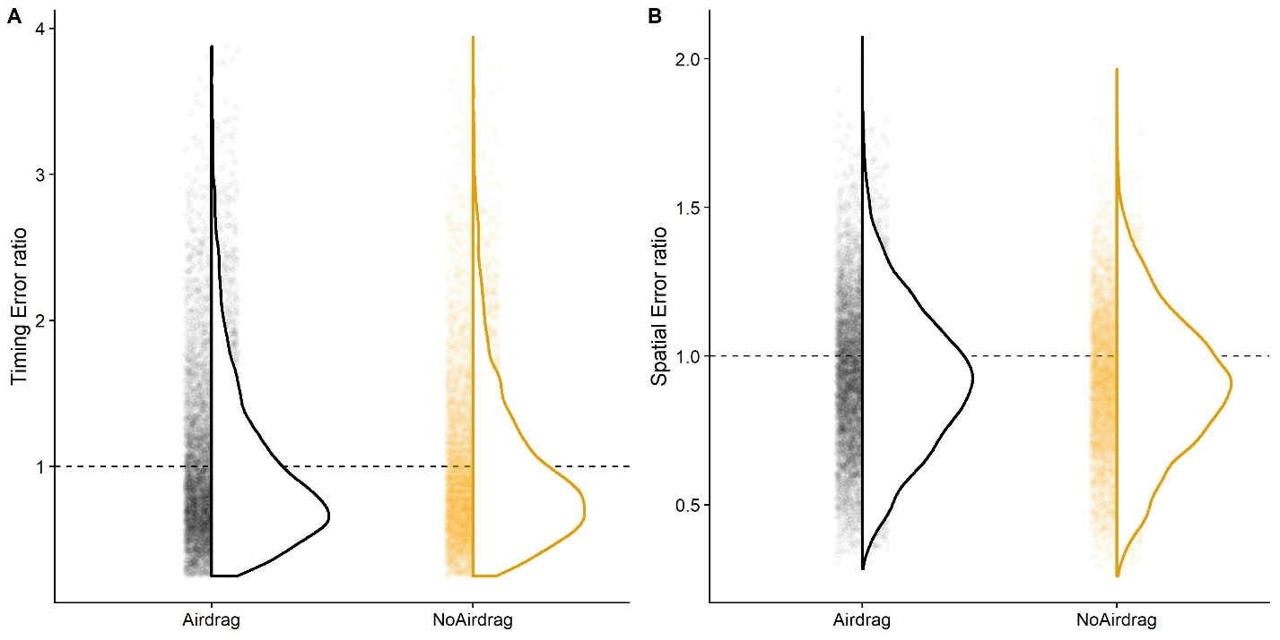

Figure : Distribution of responses error ratios for Airdrag and No Airdrag. Each small transparent dot represents one trial. The dotted line indicates a timing error ratio of 1, that is perfect accuracy. A. Timing task. B. Spatial task.

### Hypothesis 2: The influence known physical property of targets on motion extrapolation

We expect humans to perform accurately regardless of the target type when air drag is present when the physical properties correspond to the visible properties of the target. For the Tennis Ball, Incongruent condition, we expect responses to be slightly later than for the Tennis Ball, Congruent condition. For the Basket Ball, Incongruent condition, we expect responses to be slightly earlier than for Basket Ball, Congruent (*Prediction 2a*). We employ Linear Mixed Modelling implemented in the package lme4 (Bates et al., 2015; Bürkner, 2018) for R for both timing and spatial responses. For the timing responses, the model contains ball type (“Tennis”, “Basket”), congruency between visual and physical properties (“Congruent”, “Incongruent”) and their interaction as fixed effects and random intercepts per participant as random effects. In brms syntax, the model is specified as follows.

|  |  |
| --- | --- |
|  | [21] |

To ascertain whether the data support our predictions, we compared this Test Model to a Null Model that doesn’t contain the interaction term. In lme4 syntax, it is specified as follows:

|  |  |
| --- | --- |
|  | [22] |

A Likelihood Ratio Test (anova() function in R) showed that the Test Model is not significantly better than the Test Model (p = 0.778); our Hypothesis 2a is thus not supported by the data. However, it was quite unlikely to observe an effect in this condition as the expected differences in the temporal domain between the congruent and incongruent conditions were extremely small (between 2 and 8 s).

We perform the same procedure for the spatial task (*Prediction 2b*). Here we compare the Test Model

|  |  |
| --- | --- |
|  | [23] |

to the Null Model

|  |  |
| --- | --- |
|  | [24] |

again with a Likelihood Ratio Test (anova() function in R). The Test Model proved to be significantly better than the test model (p < 2.2*10^16). It estimates the regression coefficient for the interaction of Ball Type: Basketball and Congruency: Incongruent -0.063 (SE = 0.007), which is the predicted direction. We visualize the response distribution for each combination of ball type and congruency level in Figure 3. Our Hypothesis 2b, namely that humans use visual cues (such as texture) about their targets to predict their air drag-related behavior in the spatial domain, is thus supported by the data.

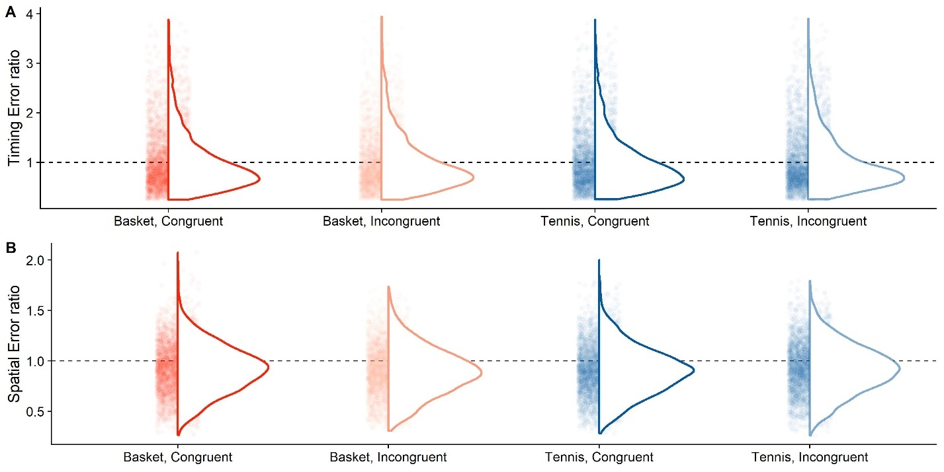

Figure : Distribution of errors per ball type and congruency condition. Each transparent dot represents one trial. The dotted line represents an error ratio of 1, that is perfect accuracy. A. Timing errors. B. Spatial errors.

## Exploratory Analyses

We furthermore explore several potential candidate hypotheses for future confirmation.

### Is precision lower when no air drag is presented in the visible part of the trajectory?

Humans might pick up subtle difference in trajectories unfolding with or without air drag, which might lead to more variable responses. And indeed, Figure 2 suggests that there might be variability differences between the Airdrag: Present and Air Drag: Absent conditions, especially in the timing task. To test this hypothesis, we use the Bayesian Mixed Models fitted above (Equation XX for the temporal responses and Equation XX for the spatial responses) and test the hypothesis that Air Drag: Absent leads to a loss in precision. For the timing task, we find that XXX

We can thus conclude that XXX

### Does variability in responses differ between congruent and incongruent trials?

It stands to reason that a conflict between texture and other physical (air drag-relevant) properties could lead subjects to extrapolate motion less precisely. As testing for variability differences is not straight-forward with traditional Linear Mixed Models, we again employ Bayesian Linear Mixed Modelling. We establish a Test Model with Congruency (“Congruent”, “Incongruent”) as fixed effect and random intercepts per participant as random effects:

|  |  |
| --- | --- |
|  | [25] |

For the hypothesis that Congruency: Incongruent leads to a higher variability in responses in the timing task (-0.03 s; SE = 0.02 s, on a log scale), we found a Posterior Probability of nearly 1 and a Evidence Ratio of 399. This indicates very strong evidence that an incongruency between texture and other physical properties leads to higher variability in responses.

We then repeat the same procedure for the spatial task. The specified model is:

|  |  |
| --- | --- |
|  | [26] |

Here, we also find variability to be higher in the timing task (-0.03 m; SE = 0.02 m, on a log scale), with a Posterior Probability of 0.97 and an Evidence Ratio of 31. This represents moderate-to-strong evidence that variability in the spatial task is indeed higher for the Congruency: Incongruent condition.

Overall, both the timing task and the spatial task present strong evidence that incongruency between texture and other air drag-relevant properties of the object leads to lower precision in responses.

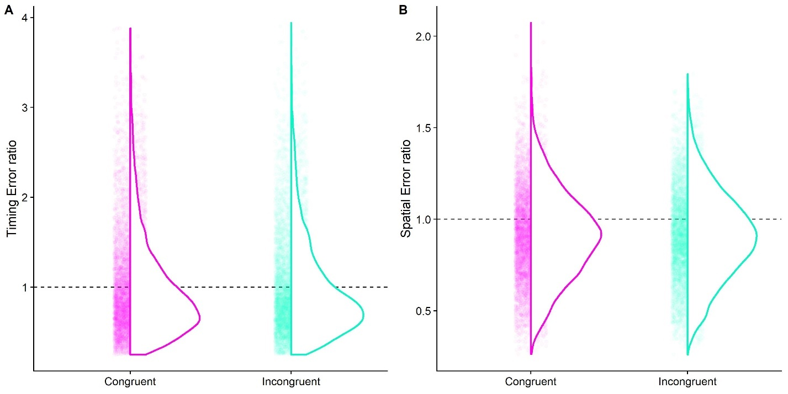

Figure : Distribution of errors for trials where the ball texture was congruent with its size and other physical properties (Congruent) and where they were incongruent (Incongruent). The dotted line represents an error ratio of 1, that is perfect accuracy. A. Timing errors. B. Spatial errors.

### Do different object sizes elicit differences in conditions?

It is furthermore possible that performance is affected by the simulated objects. For example, performance for tennis ball-sized targets (Tennis Ball, Congruent and Basketball, Incongruent) could be less precise because they are smaller, which might lead to a less precise representation of their size. Figure 5 gives some indication that there might be difference, especially for the spatial task. We thus employ the same procedure as in the previous section, and fit the following model, with Ball Type (“Tennis”, “Basket”) as fixed effect and random intercepts per participants as random effects:

|  |  |
| --- | --- |
|  | [27] |

For the hypothesis that smaller balls lead to higher variability in timing responses, we found a Posterior Probability of XX and an Evidence Ratio of XXX ( s; SE = , on a log scale).

We conducted the same analysis for the spatial error:

|  |  |
| --- | --- |
|  | [28] |

For the hypothesis that smaller balls lead to a bias in timing responses, we found a Posterior Probability fo XX and an Evidence Ratio of XXX ( m; SE = , on a log scale).

Furthermore, depth perception is not perfect in virtual reality, so a smaller optic size of the object could lead subjects to interpret that object as further away. And if participants perceive the object as further away, they might time responses too late because the same visual flow information about the distance between the point of disappearance and the target table would correspond to a larger physical distance. This is unlikely because our trajectories are governed by earth gravity, and earth gravity has been shown to help interpret visual motion in its context (Jokisch & Troje, 2003; Lacquaniti et al., 2015; Vallortigara & Regolin, 2007). However, this process might compensate only partially for misperceptions in depth. To test this hypothesis, we use non-Bayesian Linear Mixed Modelling to fit the same test models as for the exploratory precision analyses above:

|  |  |
| --- | --- |
|  | [29] |
|  | [30] |

And compare them again Null Models without Ball Type as fixed effect:

|  |  |
| --- | --- |
|  | [31] |
|  | [32] |

We tested the Test Models against the Null Models with a Likelihood Ratio Test and found the variable “Ball Size” did not improve the model fit significantly for the temporal task (p = 0.422). For the spatial task, however, it did improve model fit significantly (p < 2.2*10^16). The regression coefficient for Ball Size: 0.12 m was 0.024 (SE = 0.002); the larger targets thus lead observers to judge objects as travelling further than smaller objects.

We thus conclude …

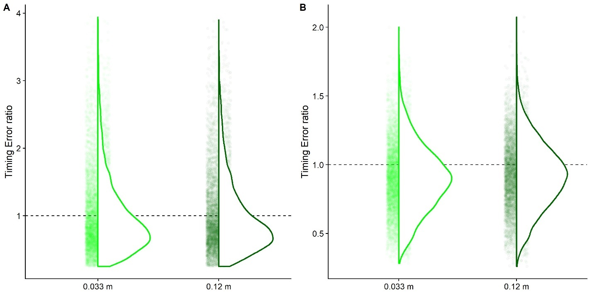

Figure : Distribution of errors for trials where the ball was of tennis ball size (0.033 m) and where the ball was of basketball size (0.12 m). The dotted line represents an error ratio of 1, that is perfect accuracy. A. Timing errors. B. Spatial errors.

### Is there a lawful relation between biases and variability?

It has recently been argued that there is a lawful, linear relationship between perceptual biases and perceptual precision (Wei & Stocker, 2017). While the authors have proposed this link for lower level perceptual processes, as employed in simple discrimination tasks, it stands to reason that similar relationships could also hold for higher level processes. To test whether our dataset supports this notion, we computed normalized standard deviations (“SD Ratio Timing” and “SD Ratio Distance”) for participant responses by computing the standard deviation per condition (horizontal velocity, time-to-contact, air drag condition, ball type and congruency condition) and participant. We then normalized the standard deviations by dividing them by the mean Occluded Time or the Occluded Distance, respectively, in the condition combination over which the standard deviation was computed. To test statistically whether there is a relationship between biases and variability, we used Linear Modelling. We fitted a simple model with the normalized standard deviations as fixed effect.

|  |  |
| --- | --- |
|  | [33] |
|  | [34] |

For both the timing task and the spatial task, the respective normalized standard deviations explained a significant amount of variability in responses. For the timing errors, the regression coefficient for SD Ratio Timing was 2.02s (SE = 0.06 s; p < 2*10^16). For the spatial errors, the regression coefficient for SD Ratio Distance was 1.947 m (SE = 0.1 m; p < 2*10^16). Note that these models do not distinguish between within-subject and between-subject variability. To determine whether this overall relationship was driven by within- or between-.subject effects, we first established Linear Mixed Models with the normalized standard deviations (“SD Ratio Timing” and “SD Ratio Distance”) as continuous fixed effects and variable intercepts per participants as random effects, with the goal of testing whether variability was significantly related to bias within-subjects. We specified the models as follows:

|  |  |
| --- | --- |
|  | [35] |
|  | [36] |

We then compared these Test Models to the following Null Models.

|  |  |
| --- | --- |
|  | [37] |
|  | [38] |

We found both Test Models to be significantly better than the Null Models. For the timing task, we found a regression coefficient for SD Ratio Timing of 0.088 s (SE = 0.038 s; p = 0.021). For the spatial task, we found a regression coefficient for SD Ratio Distance of 0.57 m (SE = 0.052; p < 2*10^16).

We tried to repeat this test with the same fixed effects, but condition combination as random effects, to assess whether participants who displayed higher variability also displayed a stronger bias. “Condition” refers here to a categorical variably where each level corresponds to one of combinations of two initial horizontal velocities, two ball sizes, two congruency conditions, presence or absence of airdrag and three times-to-contact), making for a total number of 48 levels. We thus specified two Linear Mixed Test Models with SD Ratio Timing and SD Ratio Distance as fixed effects and variable intercepts per Condition, respectively, and the corresponding Null Models without the fixed effects. We could, however, not proceed to a comparison between Test and Null Models because the random intercepts per Condition were not sufficiently different, which resulted in a singular fit. That is, the model basically omitted the random effect and estimated a regular Linear Model instead, thus not allowing us to assess the impact between-subject variability separately. We thus employed Bayesian Linear Mixed Modelling to test this hypothesis. We fit the following models:

|  |  |
| --- | --- |
|  | [39] |
|  | [40] |

Using the hypothesis() function, we tested whether the fixed effects had positive regression coefficients. For the timing condition, we found a regression coefficient of 2.11 s (SE = 0.07 s), a Posterior Probability of 1 and the corresponding infinite Evidence Ratio. For the spatial task, we found regression coefficient of 1.96 m (SE = 0.09 m), a Posterior Probability of 1 and the corresponding infinite Evidence Ratio.

We find thus compelling, albeit exploratory, evidence that both within-subject and between-subject variability in both the timing and the spatial task were linked to biases. Figure 1 represents a graphical depiction of the relationship between response variability and response bias.

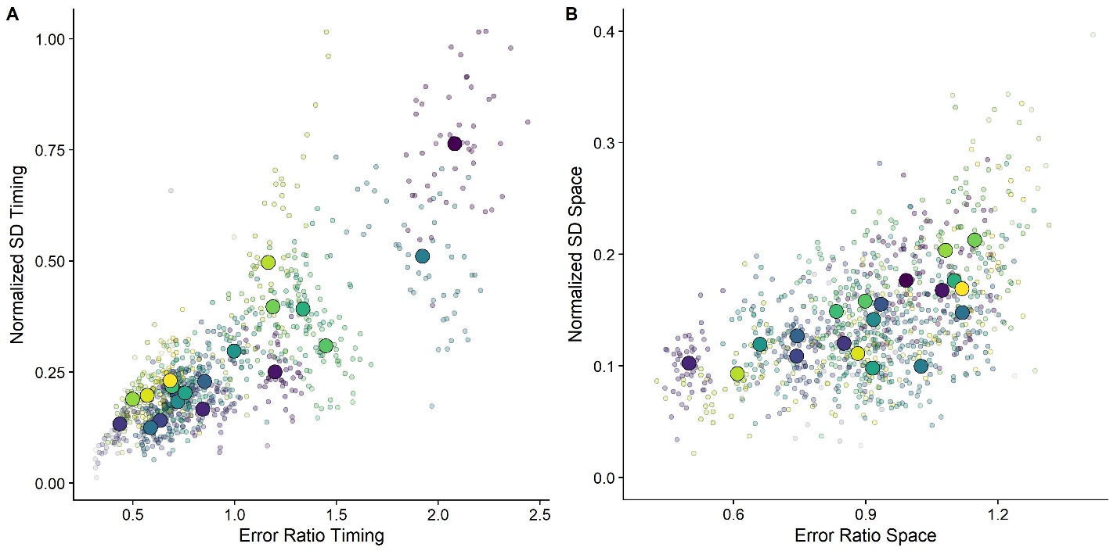

Figure 6: Error Ratios plotted against normalized standard deviations. Big dots denote the means per subject and smaller transparent dots denote the means per Condition combination. Participants are color-coded. A. Timing Task. B. Spatial Task.

## References

Adams, W. J., Graf, E. W., & Ernst, M. O. (2004). Experience can change the “light-from-above” prior. *Nature Neuroscience*, *7*(10), 1057–1058. https://doi.org/10.1038/nn1312

Bates, D., Mächler, M., Bolker, B. M., & Walker, S. C. (2015). Fitting linear mixed-effects models using lme4. *Journal of Statistical Software*, *67*(1). https://doi.org/10.18637/jss.v067.i01

Bosco, G., Delle Monache, S., Gravano, S., Indovina, I., La Scaleia, B., Maffei, V., … Lacquaniti, F. (2015). Filling gaps in visual motion for target capture. *Frontiers in Integrative Neuroscience*, *9*. https://doi.org/10.3389/fnint.2015.00013

Bürkner, P. C. (2018). Advanced Bayesian multilevel modeling with the R package brms. *R Journal*, *10*(1), 395–411. https://doi.org/10.32614/rj-2018-017

Chadwick, S. G., & Haake, S. J. (2000). The drag coefficient of tennis balls. *Proceedings of the 3rd International Confernce on the Engineering of Sport*, (January 2000), 169–176.

Gómez, J., & López-Moliner, J. (2013). Synergies between optical and physical variables in intercepting parabolic targets. *Frontiers in Behavioral Neuroscience*, *7*(May), 46. https://doi.org/10.3389/fnbeh.2013.00046

Hosking, S. G., & Crassini, B. (2010). The effects of familiar size and object trajectories on time-to-contact judgements. *Experimental Brain Research*, *203*(3), 541–552. https://doi.org/10.1007/s00221-010-2258-7

Indovina, I., Maffei, V., Bosco, G., Zago, M., Macaluso, E., & Lacquaniti, F. (2005). Representation of visual gravitational motion in the human vestibular cortex. *Science (New York, N.Y.)*, *308*(April), 416–419. https://doi.org/10.1126/science.1107961

Jokisch, D., & Troje, N. F. (2003). Biological motion as a cue for the perception of size. *Journal of Vision*, *3*(4), 252–264. https://doi.org/10.1167/3.4.1

Jörges, B., & López-Moliner, J. (2019). Earth-Gravity Congruent Motion Facilitates Ocular Control for Pursuit of Parabolic Trajectories. *Scientific Reports*, *9*(1). https://doi.org/10.1038/s41598-019-50512-6

Jörges, Björn, & López-Moliner, J. (2017). Gravity as a strong prior: Implications for perception and action. *Frontiers in Human Neuroscience*, Vol. 11. https://doi.org/10.3389/fnhum.2017.00203

Jörges, Björn, & López-Moliner, J. (2020). Characterizing the Strong Earth Gravity Prior. *PsyArXive*, 1–19. https://doi.org/10.31234/osf.io/exp93

La Scaleia, B., Zago, M., Moscatelli, A., Lacquaniti, F., & Viviani, P. (2014). Implied dynamics biases the visual perception of velocity. *PLoS ONE*, *9*(3). https://doi.org/10.1371/journal.pone.0093020

Lacquaniti, F., Bosco, G., Gravano, S., Indovina, I., La Scaleia, B., Maffei, V., & Zago, M. (2015). Gravity in the Brain as a Reference for Space and Time Perception. *Multisensory Research*, *28*(5–6), 397–426. https://doi.org/10.1163/22134808-00002471

Lacquaniti, F., Bosco, G., Indovina, I., La Scaleia, B., Maffei, V., Moscatelli, A., & Zago, M. (2013). Visual gravitational motion and the vestibular system in humans. *Frontiers in Integrative Neuroscience*, *7*(December), 101. https://doi.org/10.3389/fnint.2013.00101

López-Moliner, J., Field, D. T., & Wann, J. P. (2007). Interceptive timing: prior knowledge matters. *Journal of Vision*, *7*, 1–8. https://doi.org/10.1167/7.13.11

McIntyre, J, Zago, M., & Berthoz, A. (2001). Does the Brain Model Newton’s Laws. *Nature Neuroscience*, *12*(17), 109–110. https://doi.org/10.1097/00001756-200112040-00004

McIntyre, Joseph, Zago, M., Berthoz, A., & Lacquaniti, F. (2003). The Brain as a Predictor: On Catching Flying Balls in Zero-G. In J. C. Buckey & J. L. Homick (Eds.), *The Neurolab Spacelab Mission: Neuroscience Research in Space* (pp. 55–61). National Aeronautics and Space Administration, Lyndon B. Johnson Space Center.

Mijatovic, A., La Scaleia, B., Mercuri, N., Lacquaniti, F., & Zago, M. (2014). Familiar trajectories facilitate the interpretation of physical forces when intercepting a moving target. *Experimental Brain Research*, *232*(12), 3803–3811. https://doi.org/10.1007/s00221-014-4050-6

Neupärtl, N., Tatai, F., & Rothkopf, C. A. (2020). Intuitive physical reasoning about objects ’ masses transfers to a visuomotor decision task consistent with Newtonian physics Author summary. *BioRxiv*, 1–32.

Okubo, H., & Hubbard, M. (2010). Identification of basketball parameters for a simulation model. *Procedia Engineering*, *2*(2), 3281–3286. https://doi.org/10.1016/j.proeng.2010.04.145

Peters, M. A. K., Ma, W. J., & Shams, L. (2016). The Size-Weight Illusion is not anti-Bayesian after all: a unifying Bayesian account. *PeerJ*, *4*, e2124. https://doi.org/10.7717/peerj.2124

R Core Team. (2017). *A Language and Environment for Statistical Computing. R Foundation for Statistical Computing,*. Retrieved from http://www.r-project.org/.

Senot, P., Zago, M., Lacquaniti, F., & McIntyre, J. (2005). Anticipating the Effects of Gravity When Intercepting Moving Objects: Differentiating Up and Down Based on Nonvisual Cues. *Journal of Neurophysiology*, *94*(6), 4471–4480. https://doi.org/10.1152/jn.00527.2005

Senot, P., Zago, M., Le Seac’h, a., Zaoui, M., Berthoz, a., Lacquaniti, F., & McIntyre, J. (2012). When Up Is Down in 0g: How Gravity Sensing Affects the Timing of Interceptive Actions. *Journal of Neuroscience*, *32*(6), 1969–1973. https://doi.org/10.1523/JNEUROSCI.3886-11.2012

Stan Development Team. (2016). *Stan: the R interface to Stan. R package version 2.14.1*. 1–23. Retrieved from http://mc-stan.org

Vallortigara, G., & Regolin, L. (2007). Gravity bias in the interpretation of biological motion by inexperienced chicks. *Current Biology*, *16*(September), R279–R280.

Wei, X. X., & Stocker, A. A. (2017). Lawful relation between perceptual bias and discriminability. *Proceedings of the National Academy of Sciences of the United States of America*, *114*(38), 10244–10249. https://doi.org/10.1073/pnas.1619153114

Zago, M., La Scaleia, B., Miller, W. L., & Lacquaniti, F. (2011). Coherence of structural visual cues and pictorial gravity paves the way for interceptive actions. *Journal of Vision*, *11*(10), 1–10. https://doi.org/10.1167/11.10.13.Introduction